The study of income and living conditions of the Slovakia’s households and its macroeconomic aspects

Ladislav Kabat
Professor
The Pan European University, Bratislava

Abstract
This paper is oriented toward two key goals. The first one is oriented on analysis and presentation of the core findings under the European Union project on Statistics on Income and Living Conditions over the 2005-2009 in Slovakia. Particularly we are oriented on study of the socially vulnerable groups of population identified according their income situation. As a sorting criterion for this purpose we use the standard methodology set by OECD and Eurostat. It means the 60% of the national median of the equivalized disposable income variable is applied for this criterion as the poverty threshold. By this procedure the households of various structures are transformed onto generally accepted scale. The special attention of our study is oriented on the cluster of population living on income below the poverty threshold.
The second goal of the paper is devoted to study of relation among the core macroeconomic indicators (GDP per capita, GDP annual growth) within Visegrad countries (Czech republic, Hungary, Poland, Slovakia, Slovenia) and the level and size of the at-risk-of-poverty population during the period of last economic development, including both economic growth and economic recession. According our tentative findings we did not find the significant impact of economic growth on the income status of socially vulnerable population. This finding however should be studied in broader context, with longer time series of relevant data and with broader set of explanatory variables.
Key words: poverty, social exclusion, at-risk-of-poverty population, poverty threshold, income median
JEL: I31, I32, I38

Introduction

The second half of the rest of the decade, recorded in Central and Eastern Europe, particularly in countries of the Visegrad Group, significant economic growth. Strong increase in foreign investment was reflected in the fast growth of gross domestic product, growth in employment and consequently in the growth of indicators of the average salaries. Most countries of this group reported a notable increase of GDP in relation to the European Union average.
During this period, also Slovakia's economy experienced a period of significant growth. This development was interrupted in the period of financial and economic crisis (2009-2010). The analysis and evaluation of this development is presented in various theoretical and practical studies. This paper focuses on analysis and presentation of the impact of economic growth on social development. Particularly we present the relation among the GDP growth and changes in selected social indicators reflecting income and social situation of the Slovakian households. As a basic information source we use the time series of the macroeconomic data produced by Eurostat as well as the specifically oriented European Union project on Statistics on Income and Living Conditions, known as EU-SILC () project.
The prime goal of this paper is to analyze the core social indicators generated by this project, particularly those measuring the proportion of the bellow-at-risk-of-poverty households and individuals in whole population. As a part of this study, the material poverty indicators and the social exclusion attributes are analyzed. The second goal is focused on identification and measuring the key economic determinant’s impact on the monetary income and social situation of the households in Slovakia.
The primary variable collected and processed under this survey is the disposable income calculated per equivalized member of the household. Based on this information and according the Eurostat methodological guidelines the generalized income situation of the country’s households is formulated and the core social indicators on the at-risk-of-poverty are calculated.
This result is used as a source of information not only on the current income situation of the households in Slovakia, but given the real picture of the collected data it offers also additional information on the social status of the Slovakia's population. The obtained data and derived information is of high value in assisting and guiding the social policies of national governments and their institutions dealing directly with the social policy implementation.
The European Union Statistics on Income and Living Conditions Project for Slovakia
Statistical survey on Income and living conditions (EU SILC 2009) was introduced in European Union since 2005 as a unified data collection survey oriented on income situation of households and individuals. This project is implemented annually on the panel data and its results offer annually significant information on the population’s income level and consequently on income differentiation. As a byproduct of processing this data we get also reliable information on poverty and social exclusion. This allows us to analyze in details the social situation of households in Slovakia as well as to compare it with the other European Union countries. This comparison is possible due to a single list of mandatory surveyed variables, implemented indicators and their definitions, statistical methods and the standardized calculations of basic indicators of poverty.
Poverty indicators provide evidence of the structure and level of poverty at the national level. They create the basis for comparing living conditions in the European Union countries. At the national level, we use these data to keep track of various aspects of poverty - e.g. on terms of household composition, health, education, but also for calculation of other indicators linked to the poverty development over time.
The basic information collected during this statistical survey is represented by the income variable. Its value is calculated for all households and all their members (those over 16 years and working) and represents the total disposable household’s income for particular year or month. Total income is further recalculated in line with the Eurostat methodology in relation to equivalized size of the households. The equivalized size of households is defined by following formula:
- the first adult member of the household is counted by coefficient 1,
- the second and all other adults are counted by coefficient 0.5.
- all children below 16, economically not active, without their own income, are counted by factor 0.3.

This special calculation procedure is enabling to calculate the new derived variable – the equivalized disposable income per member of family, which plays the key role in further studies on income situation of households in individual countries. It is shown on the scheme below:
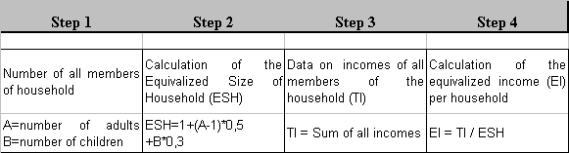
To the key political and social tasks of the European Union belongs an effort to minimize the negative social phenomena such as poverty and social exclusion. Before dealing with these tasks they need clear definition and reliable and credible statistical fulfillment. The main categories in these considerations are the concepts of the poverty and the at-risk-of poverty. The newly defined variable EI and its statistical parameters – namely mean and median values are further used to study and to compare the income situation of households of various sizes and structures and various countries. In line with the accepted methodology, the 60% of median value of its income variable is applied as a poverty line. The area below the distribution function on left to the poverty line represents the proportion (%) of households with under poverty line income in total (100%) population. In following parts the proportion of the at-risk-of poverty population according the last EU SILC data (2009) for various segments of population will be presented.
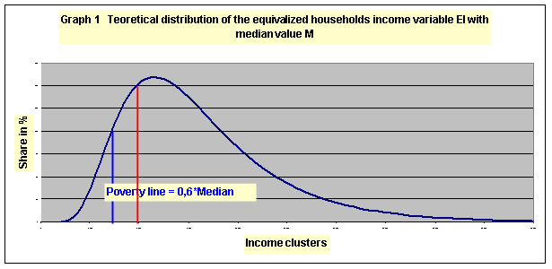
Median M MM M MMM
The last results of the EU SILC for Slovakia
The basic information on the households’ income situation for Slovakia is presented for whole period since 2005, when the first survey took place. In the following tables data on Slovakia as well as data for individual administrative regions are presented.
There are the following geographical units, recognized by the EU statistics for the EU SILC purposes - Bratislava, Trnava, Trencin, Nitra, Zilina, Banska Bystrica, Presov, Kosice. Despite the fact that Slovakia is geographically rather small country, there are quite significant differences in economic and social achievements of these administrative units. The better developed industrial infrastructure in western part of Slovakia, represented by capitol city Bratislava and regions Trnava and Trencin are reflected in direct economic indicators like GDP per capita, but also by social indicators as level of employment and level of salaries.
Table 1a shows that mean value of the income per person (equivalized) per month was 524 Euros, with median value of 473 Euros. Comparing these values for 2005 and 2009 we observe about 50% increase in characteristic, mean and median for entire Slovakia. The dynamics of the household incomes according the EU SILC data on regions shows that the highest mean value as well as the highest median value were reported for Bratislava region with 682 and 609 Euros per month. In relative terms, Table 1b, it means that the average of income variable in Bratislava region is more than 30% higher than the respective Slovak value. The median value for Bratislava is about 29% higher than the Slovakia’s value. Comparison of the Bratislava’s region median income with that of the bottom income region Presov shows relatively high disproportion between their mean and median values – 43 % and 31 %. This result is actually reflecting the problematic, not solved problems on labor market and serious problems with high unemployment rates in this region. In some districts and village settlements, with high proportion of gypsy population (30-40%) the share of unemployed people reaches 50 % and even more percent. The unemployment rate among the gypsy population reaches 80% and more. The low qualification and lack of real opportunities to find a job makes their income and social situation even worse. The social exclusion of this group of population is progressing and deepening in its forms and content. Having in mind the high birth rate of this population segment, which is estimated to become majority over several decades, makes this findings really alarming.

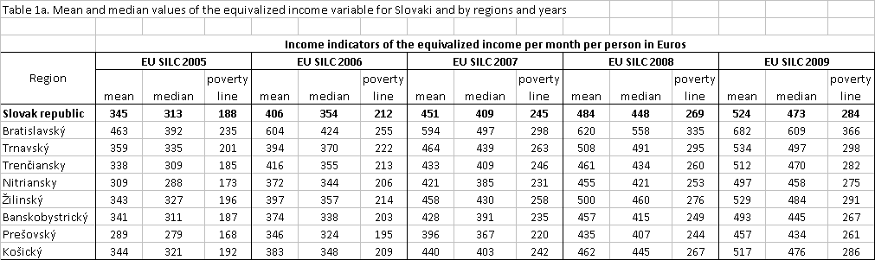

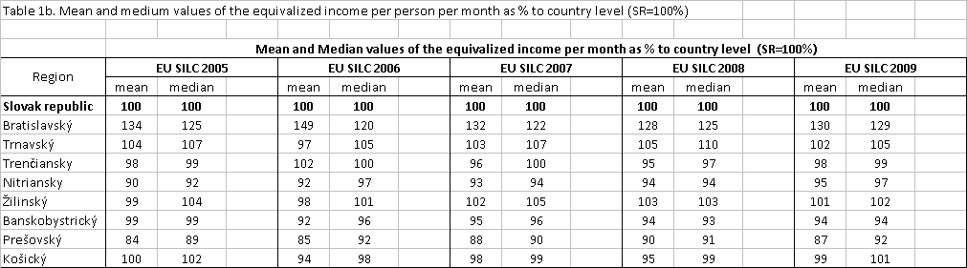
Serious long-term problem in Slovakia is a significant disproportion in regional economic and social development. The insufficient transports system, predominantly serving the western part of the county is not sufficiently assisting in attracting the investors to central and eastern part of Slovakia. Practical consequences of this unbalanced economic development are consequently reflected by many characteristics of the population living standard.

The useful findings on unbalanced economic and social development could be derived, if individual Slovak regions are compared to the Bratislava region, the one with the highest economic growth and also with the highest income level. As shown by Table 1c, the fast growing Bratislava region is ahead of the other Slovak regions about 20-30% in income level.
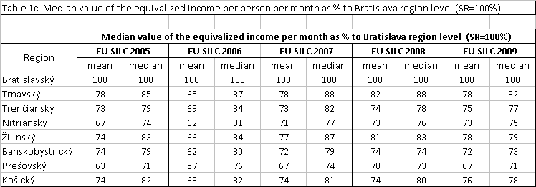
To understand these differences, it should be noted that Bratislava’s region with its 160% GDP per capita to the EU average (in 2009) occupies the 12th position among the all EU NUTS 2 regions. Contrary to this, the Eastern Slovakia’s regions (Presov and Kosice) are representing hardly 46% of the EU average GDP per capita level. These economic discrepancies among various regions are permanently eased by various social policy tools and support schemes.

The role of the social net
We studied three subgroups of the surveyed households for Slovakia. The first one is the at-risk-of-poverty population before all social transfers (PBAST), the second group is represented by the at-risk-of-poverty population before social transfers except the pension payments (survivors and old-age benefits) (PBSTEPP), while the third group is represented by the overall level of the at-risk-of-poverty population, when the disposable income of households is considered.
According the EU-SILC 2009 data, almost 11% of Slovak citizens, it means more than 595,000 people, were in 2009 at-risk-of-poverty after social transfers. In terms of gender - women are relatively more at-risk-of poverty status (11.8%) than men (10.1%). The most vulnerable group are children and youngsters till 17 years of age with 16,8 % of them at risk of poverty. Also the aged women over 65 are jeopardized by the poverty trap. Some additional indicators of the EU SILC on living standard and social exclusion for period 2005-2009 are presented in Table 2. The income situation however, is much more complicated if considered before social transfers. In case when only pensions are taken into account there is 17% of population living on income under poverty line. Alarming data is linked to the proposition of youngsters, where proportion in this category overreaches 24%. The vulnerability of population and its dependence on the government social policies is revealed by data on the before all social transfers. In this case almost 40% of total population is jeopardized by income poverty. In category of senior citizens it is even more than 86%.

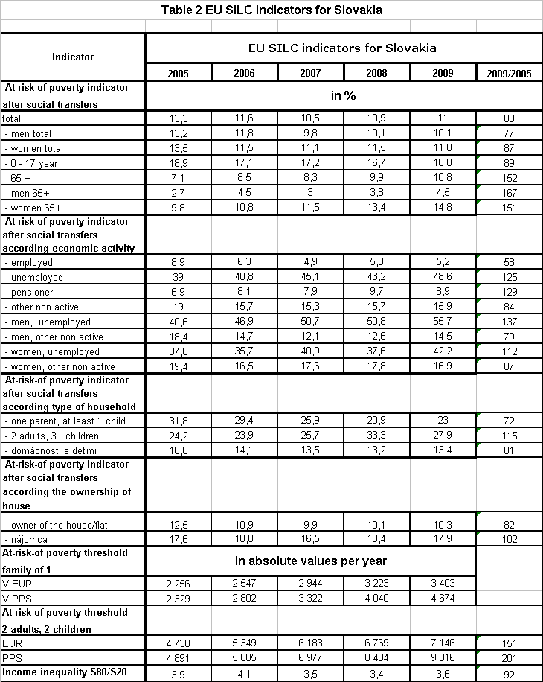
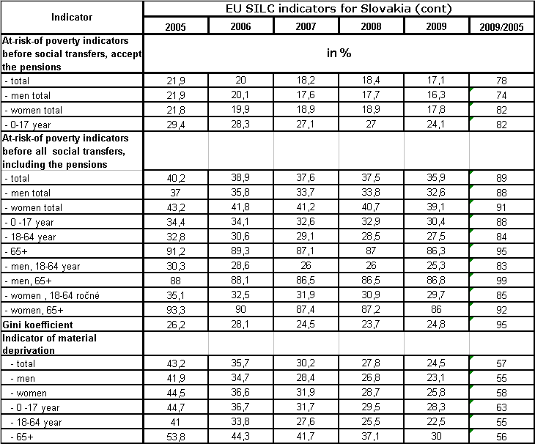
These data reflects several important findings which should be pointed out and studied in more details. According the type of the economic activity of respondents, the highest risk of poverty was identified in 2009 for unemployed citizens - 48.6%. However, even more disturbing is the dynamics of the level of unemployment over the last five year period is particularly warning. As shown on Graph 2. There is 25 % increase of number of people in this social group between 2005 and 2009. This fact is disturbing and raising concerns on impact of the results of economic growth on social environment, because in the same period Slovakia reported relatively high economic progress.

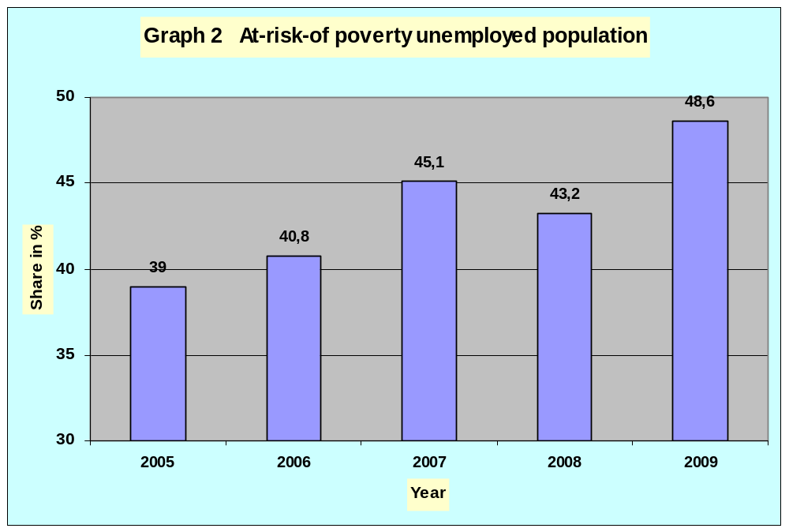
The further concerns are linked to development in income situation of the senior citizens (pensioners).The 8,9 % of them fell under the at-risk-of-poverty level. Quite obviously, the best income situation is in the group of employed people with only 5.2% of poor people. This data also shows how important for dealing with social situation are new jobs.
Among the other important factors affecting significantly the income situation of households have been identified also the size and structure of the households. Particularly, incomplete families with children are reported as highly vulnerable groups. The most vulnerable ones are also those with 3 and more depending children (27.9%), senior individuals (living alone) over 65 years (26.2%) and single parents families with children (23%). More detailed information on the rate of the at-risk-of-poverty households over last years is shown in the Table 3 for various household structures. The long-lasting findings show that senior citizens as well as the young families with children and single parent families are the most vulnerable groups concerning their income situation. Surprisingly these groups of population demonstrate the long-lasting negative development of their income situation. Understandably, quite satisfactory development is reported by households of two adults and households without children.
Table 3 At risk of poverty rate in various types of households
Type of household |  | 2006 | 2007 | 2008 | 2009
Person | male | 19.6 | 15.3 | 19.0 | 19.6
 | female | 15.7 | 17.9 | 22.5 | 24.5
 | < 65 | 19.1 | 18.2 | 21.5 | 20.0
 | 65 + | 14.8 | 16.4 | 21.9 | 26.2
Single parent | At least 1 child | 29.4 | 25.9 | 20.9 | 23.0
Two adults | 1 depending child | 8.0 | 5.9 | 9.6 | 10.5
 | 2 depending children | 13.6 | 12.3 | 10.0 | 9.9
 | 3 or more depending children | 23.9 | 25.7 | 33.3 | 27.9
Two adults | Both < 65 | 8.5 | 3.7 | 4.6 | 4.2
 | At least one 65+ | 4.1 | 3.9 | 3.6 | 3.5
Households | With depending child | 14.1 | 13.5 | 13.2 | 13.4
 | Without depending child | 7.9 | 6.5 | 7.5 | 7.7

To solve the jeopardy of the trap of income poverty requires the long-term purposefully oriented economic growth with active involvement and support from government. With the unsolved problems of long lasting high unemployment, the situation cannot be improved. This is clearly documented also by the EU-SILC 2009 data for Slovakia, where rate of population under poverty line without social support climbs to 40 %. Taking into account the pensions and survivors' benefits, the share of those living at-risk-of-poverty is much lower, but still on relatively high at 17.1 %. Such high involvement of government is administratively very complicated and often also not fully transparent. This gives us an impetus to consider the new forms of assistance to disadvantaged (poor) people as well as to address the inadequacy of income through other instruments. A possible alternative may be the minimum level pension, which is already discussed within the Slovak government.
The problem of social poverty and social exclusion is a multidimensional social problem and should not be reduced to the income deficiency. Statistical data on income collected under the Project clarify this problem only partially. It is therefore necessary to map the social situation of the population in the broader context and through more quantitative and qualitative indicators. For example, despite the relatively low proportion of the under-poverty line living people (11%), the answers to the question How the household is able to make ends meet (to pay for its usual necessary expenses) on the scale ranging from 1-we are not able to live on this money to 5-easily about 70 % of families are reporting various levels of problems with living on their actual income.
The further supplementary information on social and particularly on material situation of households could be derived from the complex indicator Material deprivation rate. It is defined as follows : material deprivation rate is proportion of population with enforced lack of at least three (or four) out of nine following items, the household cannot afford: a) to face unexpected expenses, b) to go on one week annual holiday away from home, c) to pay for arrears (mortgage or rent, utility bills or hire purchase installments), d) to eat meal with meat, chicken or fish every second day, e) to keep home adequately warm, or could not afford (even if household wanted to): f) a washing machine , g) a color TV, h) a telephone and i) a personal car. The distribution of respondents is shown in Table 4. Comparing their answers with the previous information we find that material deprivation is apparently felt much stronger, than the income poverty indicators show.
Table 4 Material deprivation rate
Number of missing items | 2005 | 2006 | 2007 | 2008 | 2009
Number of missing items | Proportion of households in %
3 | 43.2 | 35.7 | 30.2 | 27.8 | 24.5
4 | 22.5 | 18.3 | 13.7 | 11.8 | 11.1

In order to understand better the dynamics in some selected social indicators, the share of population living under the poverty line and the share of population living on twice and three times average income is shown. According this data proportion of population living under poverty line is rather stable with 11 and 12.8 % in total population despite the economic growth and significant GDP increase. The proportion of the population in high income clusters (twice and tree times over the average income) is more sensitive on the country´s economic results. The favorable economic growth before the economic crisis is reflected in high proportion of population living with equivalized income over 2 and 3 times average income.
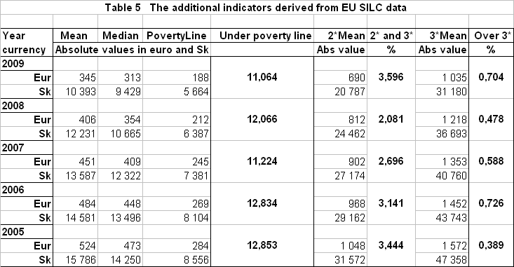
This situation is shown on Graph 3.
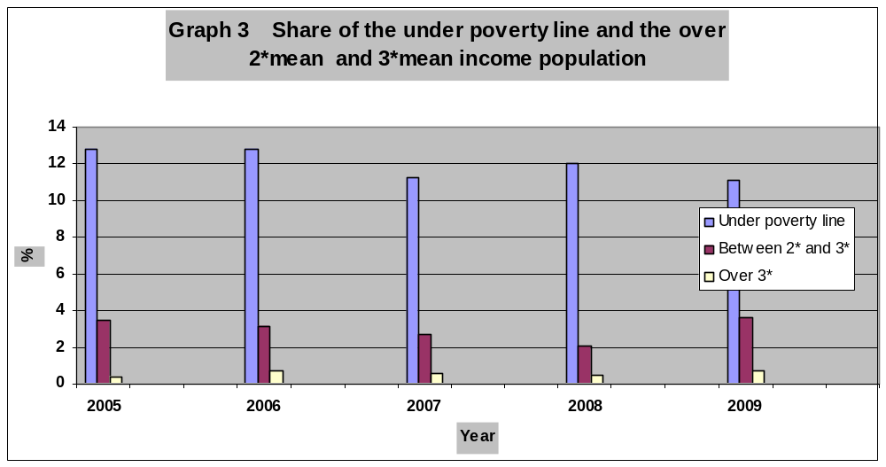
Because of short time series, we cannot derive the relevant regression functions enabling us to analyze exactly the relation between GDP growth and changes in the size of all these groups. However, as shown on the Graph 4 these data indicate relatively low impact of the economic growth (presented by GDP per capita) and at-risk-of-poverty population. Particularly low impact is recorded during the period of strong economic growth 2005-2008.
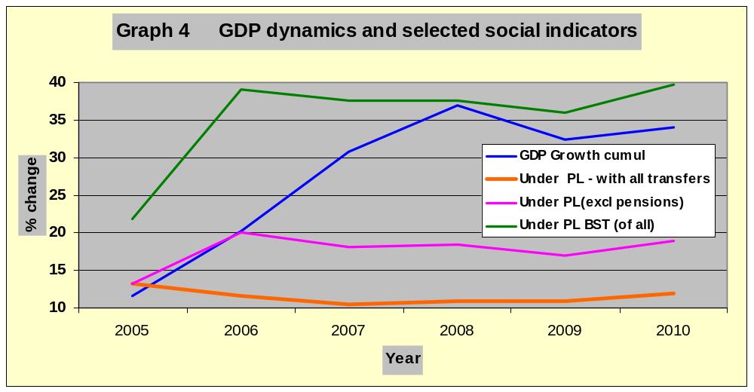
By considering the additional explanatory data we can find that the vulnerable groups of population are in “relatively safe” status (relatively low share of the at-risk-of-poverty population) mostly due to various social supporting schemes (). For 2005-2008 period such an assistance reached relatively high level and its average share in national GDP was close to 16%.
Generally, the above presented results have not proved the expected impact of the economic growth on situation of the socially excluded population in Slovakia and similar situation is observed also in other Visegrad countries. These partial findings however should be studied under the broader frame of explanatory variables and also under the longer time span.
The selected macroeconomic data on EU, Slovakia and Visegrad countries with related social indicators
Majority of EU countries, including countries of the Visegrad group, report for recent years (2005-2009) good results of their economic growth (). As seen from Table 6, these countries in 2005 reported their national GDP, when compared to the average of the EU, between 51% level in Poland and 87% level in Slovenia with Slovakia’s 60% level. Also the annual increase of GDP in these countries was significantly higher (except the Hungary and Slovenia) than in old majority of EU member countries. This positive development was partially interrupted by a period of financial and economic.
Table 6 GDP per capita in PPS compared to EU average (EU=100%)
 | 2005 | 2006 | 2007 | 2008 | 2009
EU | 100 | 100 | 100 | 100 | 100
CR | 76 | 77 | 80 | 80 | 80
HU | 63 | 63 | 63 | 64 | 63
PL | 51 | 52 | 54 | 56 | 61
SR | 60 | 63 | 68 | 72 | 72
SLO | 87 | 88 | 89 | 91 | 86
As presented above, Slovakia achieved the highest GDP growth among these countries when comparing their economic dynamics to the European Union average. During the 2005-2009 period this GDP growth achieved almost 12%, while in Czech republic it was only 4%, in Hungary 0%, Poland 10% and Slovenia reported even downfall of -1%. In order to understand impact of the economic growth on the vulnerable groups of population, the data on development in the at-risk-of poverty level for individual Visegrad countries are presented in Table 7.
Table 7 At risk of poverty population in Visegrad countries
 | 2005 | 2006 | 2007 | 2008 | 2009
EU | 16,4 | 16,5 | 16,4 | 16,4 | 16,3
Czech rep | 10,4 | 9,9 | 9,6 | 9 | 8,6
Hungary | 13,5 | 15,9 | 12,2 | 12,4 | 12,4
Poland | 20,5 | 19,1 | 17,3 | 16,9 | 17,1
Slovakia | 13,3 | 11,6 | 10,5 | 10,9 | 11
Slovenia | 12,2 | 11,6 | 11,5 | 12,3 | 11,3

Comparing these data with cumulative GDP growth however the level of the at-risk-of-poverty population has not decreased in all countries adequately to their economic growth with only small changes in structure of income distribution, as shown in Table 8. According these the was significant decrease in value of Gini coefficient in Poland.
Table 8 Gini coefficients for Visegrad countries
Region - Country | 2005 | 2006 | 2007 | 2008 | 2009
European Union | 30,6 | 30,2 | 30,6 | 30,7 | 30,4
Czech Republic | 26,0 | 25,3 | 25,3 | 24,7 | 25,1
Hungary | 27,6 | 26,3 | 25,6 | 25,2 | 24,7
Poland | 35,6 | 33,3 | 32,2 | 32,0 | 31,4
Slovenia | 23,8 | 23,7 | 23,2 | 23,4 | 22,7
Slovakia | 26,2 | 28,1 | 24,5 | 23,7 | 24,8

The presented data on economic performance of the EU and Visegrad countries (Table 6) show relatively well functioning economic system. However, these data do not show the significant positive impact on the social status of population, particularly those living under the at-risk-of-poverty (). These findings however cannot be generalized and require deeper study over longer time series data, which will be the next part of our research study.
Final conclusion
Based on the reported outcomes of the EU-SILC project we found that the core social problems of Slovakia – particularly the high share of socially vulnerable population has not changed significantly during the period of strong economic growth in Slovakia. Similar development has been found also in other Visegrad countries. We did not prove the expected impact of economic growth on dynamics in indicators reflecting the social positions of population in these countries. This finding however should be studied in more details and taking into account longer time series on relevant statistical data as well as the broader set of explanatory variables.

Literature:

Eurostat: Combating Poverty and Social Exclusion, Brussels, 2010
Slovak Ministry of Social Affairs: Program document of the Slovak Government, August 2010
Eurostat: Government Finance Statistics, Data 1996-2009, Brussels, 2010
Kabat, L.: New approaches to measurement of economic growth and social progress, in Firma a konkurenční prostředí, Mendel University, Brno, 2009

